Jira Sprint Planning and Task Management
This document explains how Jira is used to plan and manage the Healthcare Insurance Data Analytics project. A Scrum-based approach is followed to divide the work into tasks and track progress using a sprint.
Sprint Details
Sprint Name: Sprint 1 – Healthcare Insurance Data Analytics
Duration: 2 Weeks
Start Date: 20 April 2026
End Date: 4 May 2026
The sprint is divided into two parts:
Week 1: Documentation and Design
Week 2: Implementation and Testing
Task Organization
The work is divided into two main tasks:
- Documentation For Project
- Create SRS Document
- Create Solution Design Document
- Design Database Schema
- Create ER Diagram
- Implementation and Testing
- Setup PySpark Project
- Data Ingestion
- Data Cleaning
- Data Processing
- Implement 13 Use Cases
- Testing and Validation
Each task is divided into smaller subtasks to make the work easier to manage and track.

Jira User Stories
The following user stories are created to represent business requirements:
- As a business analyst, I want to find the disease with maximum number of claims so that I can identify high-risk diseases.
- As a data analyst, I want to find subscribers with age less than 30 so that I can analyze young customer trends.
- As a manager, I want to find which group has the maximum number of subgroups so that I can understand policy distribution.
- As an analyst, I want to find the total number of rejected claims so that I can evaluate claim rejection rate.
- As a business user, I want to calculate the average monthly premium so that I can understand revenue trends.
- As a business analyst, I want to find the hospital that serves the most number of patients so that I can identify the most active hospital in the network.
- As a data analyst, I want to find which subgroup is subscribed the most number of times so that I can understand which policy subgroup is most popular among subscribers.
- As a manager, I want to find the city from which the most claims are coming so that I can identify high claim areas and plan accordingly.
- As a business analyst, I want to find which group subscribers prefer most — Government or Private so that I can understand customer policy preferences.
- As a manager, I want to find which policy group is the most profitable so that I can focus on the most revenue generating policies.
- As a business analyst, I want to list all patients below age 18 admitted for cancer so that I can identify young cancer patients for special insurance plans.
- As a business analyst, I want to list patients with cashless insurance and total charges greater than or equal to Rs. 50,000 so that I can identify high cost cashless claims.
- As a business analyst, I want to list female patients over age 40 who had knee surgery in the past year so that I can identify patients who may need special coverage.

Test Cases
The following test cases are created to validate the outputs of the system:

Test Case ID | Description | Input | Expected Output
TC01 | Find disease with maximum claims | Claims data | Correct disease with highest number of claims
TC02 | Find subscribers with age < 30 | Subscriber data | Only records with age less than 30
TC03 | Find group with maximum subgroups | Group/Subgroup data | Correct group with highest subgroups
TC04 | Find hospital serving most patients | Hospital + patient data | Correct hospital name
TC05 | Find most subscribed subgroup | Subscriber data | Correct subgroup with highest count
TC06 | Count total rejected claims | Claims data | Correct rejected claims count
TC07 | Find city with most claims | Claims + patient data | Correct city with highest claims
TC08 | Find preferred group (Gov/Private) | Subscriber data | Correct group preference
TC09 | Calculate average monthly premium | Subscriber data | Correct average value
TC10 | Find most profitable group | Subscriber + claims data | Correct group
TC11 | List patients below 18 with cancer | Patient + claims data | Correct filtered list
TC12 | List cashless patients with charges ≥ 50,000 | Claims data | Correct filtered list
TC13 | List female patients > 40 with knee surgery | Patient + claims data | Correct filtered list

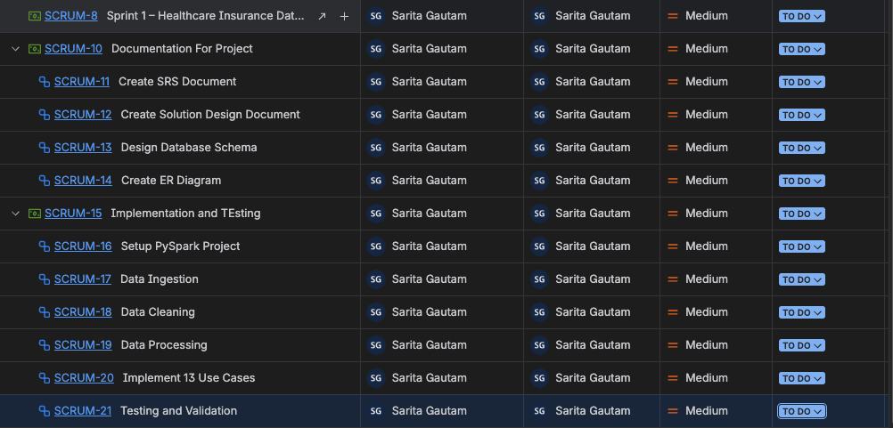 Initial Jira Board – All tasks are in Idea/To Do stage
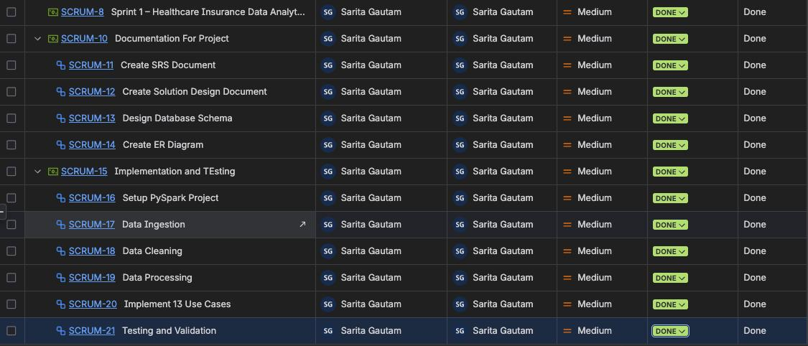 Final Jira Board – Documentation tasks moved to Done stage

At the beginning of the sprint, all tasks were created and kept in the Idea or To Do stage. As the documentation work was completed, the tasks were moved to the Done column. This shows the progress of the project and how Jira helps in tracking task completion.
Jira helped in organizing the project work, dividing tasks into smaller steps, and tracking progress clearly. It ensured that the project followed a structured approach and was completed in a planned manner.

